Edgewood High School

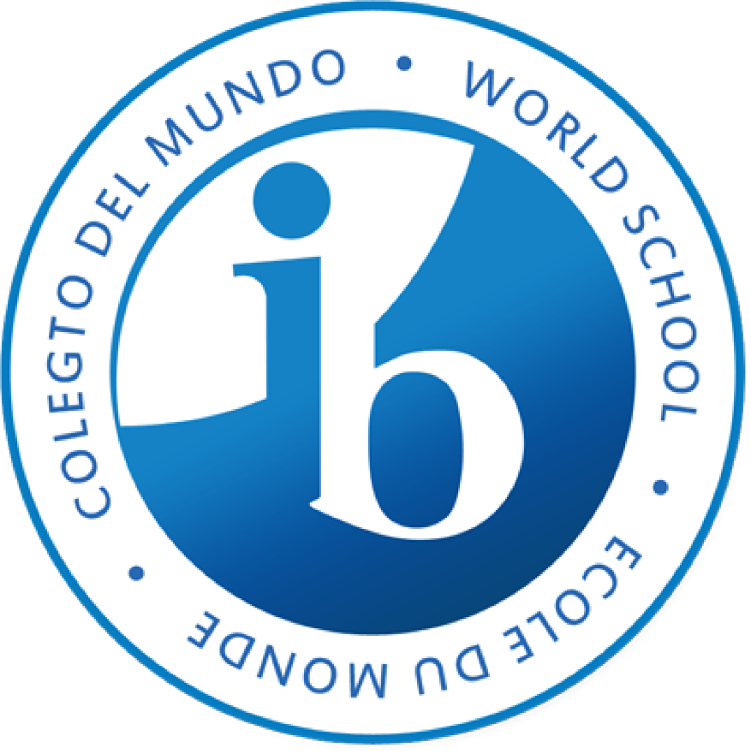

Creativity, Activity, and Service (CAS) Handbook

Table of Contents

What is CAS?.................................................................................................................................................3

CAS Requirements……………………………………………………………………………………………………..……………………………4

CAS Learning Outcomes…………………………………………………………………………………………………..…………………..5-6

What is a CAS Experience?........................................................................................................................7-8

CAS Project………………………………………………………………………………………………………………………………………………9

Planning for CAS Experiences and CAS Projects……………………………………………………………………………………..10

COVID 19 Policy……………………………………………………………………………………………………………………………………..11

Schedule and Timelines………………………………………………………………………………………………………………………...12

Reflection………………………………………………………………………………………………………………………………………………13

Student Resources………………………………………………………………………………………………..………………………….14-22
- CAS Program Completion Student Checklist
- CAS Project Form
- CAS Project Detail Form
- CAS Project Risk Assessment
- Using Managebac

The information and images in this handbook were taken directly from the CAS Guide on www.ibo.org

What is CAS?

CAS stands for creativity, activity, and service. It is at the heart of the IB Diploma Program and is designed to strengthen and extend students’ personal and interpersonal.
Important Definitions:
- Creativity—exploring and extending ideas leading to an original or interpretive product or performance.
- Activity—physical exertion contributing to a healthy lifestyle.
- Service—collaborative and reciprocal engagement with the community in response to an authentic need.
CAS enables students to demonstrate attributes of the IB learner profile in real and practical ways.
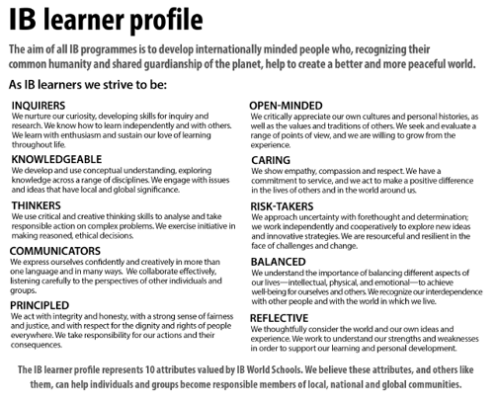
Source: www.ibo.org

CAS also enables students to grow as unique individuals and to recognize their role in relation to others.
During a students CAS program, students develop skills through a variety of individual and group experiences that allows each student to explore their interests and express their passions, personalities and perspectives.
CAS complements our academic program and can be found in each of our course syllabus.
CAS Requirements
Successful completion of CAS is a requirement for the award of the IB Diploma.
Students will be required to keep a CAS portfolio (which is done virtually through a program called managebac) where they log their CAS experiences, CAS project, documentation, and reflections.

Through the reflections in their CAS portfolio, students MUST demonstrate that they have achieved each of the seven CAS learning outcomes throughout their CAS experiences (each of which are described on the next page):

- Learning outcome 1: Identify own strengths and develop areas for growth
- Learning outcome 2: Demonstrate that challenges have been undertaken, developing new skills in the process
- Learning outcome 3: Demonstrate how to initiate and plan a CAS experience
- Learning outcome 4: Show commitment to and perseverance in CAS experiences
- Learning outcome 5: Demonstrate the skills and recognize the benefits of working collaboratively
- Learning outcome 6: Demonstrate engagement with issues of global significance
- Learning outcome 7: Recognize and consider the ethics of choices and actions

It is also expected that students to have a reasonable balance between creativity, activity, and service through their portfolio. A portfolio containing all activity entries for example will not meet the requirements for graduation.

Your CAS coordinator will review your portfolio throughout the year and discuss with you your progress towards meeting each of these learning outcomes and balance of experiences.

There are three formal documented interviews students must have with their CAS coordinator
- At beginning of the CAS program
- At the end of the first year
- At the end of the CAS program
During the third interview, if all of the requirements are met, your CAS coordinator will then “sign off” on your portfolio signifying you have met the CAS requirement for graduation from the IB program.

CAS Learning Outcomes

Learning outcome 1: Identify own strengths and develop areas for growth | The student:  - is aware of own strengths and weaknesses  - is open to improvement and growth opportunities  - is able to propose experiences according to own interests and talents  - is willing to participate in different experiences  - is able to undertake a thoughtful self-evaluation  - is able to see themselves as individuals with various abilities and skills, some more developed than others.
Learning outcome 2: Demonstrate that challenges have been undertaken, developing new skills in the process | The student:  - participates in an experience that demands an appropriate personal challenge; this could be with new or familiar experiences  - is willing to become involved in unfamiliar environments and situations  - acquires new skills and abilities  - increases expertise in an established area  - shows newly acquired or developed skills or increased expertise in an established area.
Learning outcome 3: Demonstrate how to initiate and plan a CAS experience | The student:  - is able to articulate and use the CAS stages including investigation, preparation, action, reflection (ongoing) and demonstration, moving from conceiving an idea to carrying out a plan for a CAS experience or series of CAS experiences  - demonstrates knowledge and awareness by building on a previous CAS experience  - shows initiative by launching a new idea or process  - suggests creative ideas, proposals or solutions  - integrates reflective thoughts in planning or taking initiative  - is aware of roles and responsibilities when designing an individual or collective CAS experience  - shows responsible attitude to CAS project planning  - is able to develop a coherent action plan.
Learning outcome 4: Show commitment to and perseverance in CAS experiences | The student:  - demonstrates regular involvement and active engagement with CAS experiences and CAS project  - is able to foresee potential challenges to the initial plan and consider valid alternatives and contingencies  - demonstrates adaptability to uncertainties and changes  - gets involved in long-term CAS experiences and CAS project.
Learning outcome 5: Demonstrate the skills and recognize the benefits of working collaboratively | The student:  - shares skills and knowledge  - listens respectfully to proposals from peers  - is willing to take on different roles within a team  - shows respect for different points of view and ideas  - makes valuable contributions  - is responsible for participating in the group  - readily assists others  - is able to identify, demonstrate and discuss critically the benefits and challenges of collaboration gained through CAS experiences.
Learning outcome 6: Demonstrate engagement with issues of global significance | The student:  - recognizes the global implications of local issues  - is able to identify global issues in the local or national community  - shows awareness of issues of global importance and takes concrete and appropriate actions in response to them either locally, nationally or internationally  - gets involved in CAS projects addressing global issues in a local, national or international context  - develops awareness and responsibility towards a shared humanity.
Learning outcome 7: Recognize and consider the ethics of choices and actions | The student:  - recognizes ethical issues  - is able to explain the social influences on one’s ethical identity  - takes into account cultural context when making a plan or ethical decision  - identifies what is needed to know in order to make an ethical decision  - articulates ethical principles and approaches to ethical decisions  - shows accountability for choices and actions  - is aware of the consequences of choices and actions regarding self, others involved and the community  - integrates the process of reflection when facing an ethical decision  - shows awareness of the potential and varied consequences of choices and actions in planning and carrying out CAS experiences.
Source: www.ibo.org

What is a CAS Experience?

Students will engage in CAS experiences involving one or more of the three CAS strands (creativity, activity, service). A CAS experience can be a single event or may be an extended series of events.

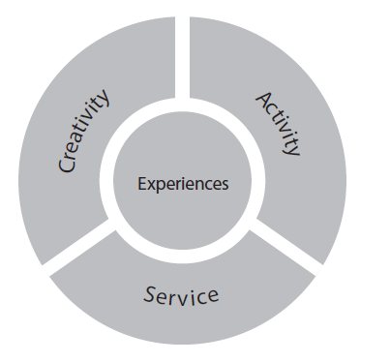
Source: www.ibo.org

A CAS experience must:
- Fit in one or more of the CAS Strands (Creativity, Activity, Service)
- Based on personal interest or opportunity for growth
- Provide a chance to develop attributes of the IB learner profile
- Cannot be included as part of your course requirements

Below is a list of just some of the possibilities for CAS experiences. There are many more, but this will give you an idea.

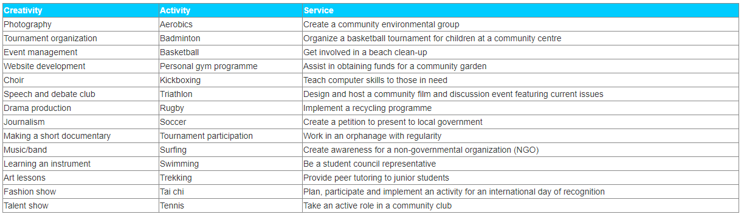
Source: www.ibo.org

Here are a couple examples that show you how you can have an experience that falls within more than one strand:

- Student Government Committee (creativity and service): A student serves the school and student body by arranging experiences that improve community within the school and by representing student voices to school management. All the planning and presenting involves significant creative problem-solving.

- Dance class (creativity and activity): The cardiovascular fitness, flexibility and muscle strength development adds up to an activity experience. The interpretation and expression of emotions through movement of the body satisfies the creativity strand.

- Home restoration for an elderly population (activity and service): This project assists with the renovation of homes for the elderly and meets the service strand. The hard physical work of renovating houses on a continual basis meets the activity strand.

CAS Project
A CAS project
- is a collaborative series of sequential CAS experiences that last at least a month in duration.
- challenges students to demonstrate perseverance, develop skills – such a problem solving and collaboration, and show initiative.
- involves collaboration between a group of students or with members of the wider community. Working collaboratively also provides opportunities for individual students to enhance and integrate their personal interests, skills and talents into the planning and implementation of CAS projects. Students work as part of a team, with all members being contributors.
- offers students the opportunity to be responsible for, or to initiate, a part of or the entire CAS project.

Your CAS project should be based around your interests and show your growth as an individual. It can be within one strand of CAS or combine 2 or 3 strands.

All CAS projects are designed with a defined purpose and goals. Individual students identify one or more learning outcomes to further guide their role and responsibilities in the CAS project. Students will likely identify more outcomes, or modify expected outcomes during the CAS project and/or at its completion. All CAS projects should use the CAS stages (see page 10) as a framework for implementation to ensure that all requirements are met.

Here are several examples of projects from the IB CAS guide:

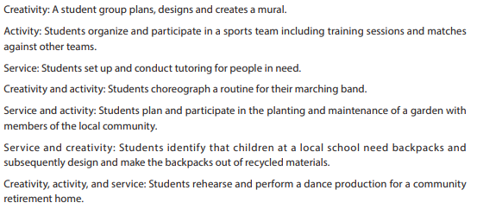
www.ibo.org

Please review and be prepared to use the 3 required CAS Project forms in the student resources section.
Planning for CAS Experiences and CAS Projects

Utilize the 5 CAS stages when planning all experiences and projected

- Investigation: Identify your interests as well as areas for personal growth
- Preparation: Clarify roles and responsibilities, develop a plan, create a timeline
- Action: Implement your plan – either individually or as a group
- Reflection: Describe what happened, raise questions, connect to your CAS learning outcomes, connect to your personal growth and accomplishments
- Demonstration: Clearly show what and how you learned in your CAS portfolio via managebac.

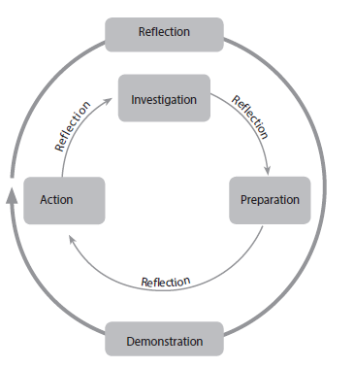
Source: www.ibo.org

COVID 19 Policy
When planning your CAS experiences and CAS project, it is essential that you follow the county, state, and national guidelines for safety during this COVID 19 Pandemic.
As of right now, you CAN NOT plan for experiences and or a project where you meet together as a group, utilize areas within the school or school grounds, or complete an individual activity outside your home without the use of a mask.
What you CAN do is plan to collaborate virtually and perform that action individually.

CAS Experience Example

Original Idea
As a group – get together to do a group Zumba workout for an experience in the activity strand
- This is fits within the parameters of a CAS experience in the activity strand, but requires you to be with a group of people not wearing a mask.

Modified
As a group – set a time to work out, choose any workout program on TV/DVD to follow, workout together virtually using a group meeting platform or workout at the same time and then meet virtually later to discuss the challenges of the workout etc.
- You still get the collaborative nature of the original experience and the activity of the original experience but it fits within the county guidelines to keep you safe since you are all working out individually.

CAS Project Example
Original Idea
As a group - Design and build a native pollinator garden at your school to help increase the populations of native butterflies that creates “green areas” around the school as well.
- This is an amazing project that meets all the requirements of a cas project. However, it does not meet the regulations set by the county during this pandemic to keep you safe – working as a group and meeting at school both violate these guidelines.

Modified
As a group – virtually design a native pollinator garden, researching required plant species as well as habitat features needed. Individually, build this area at your house.
- You are still working collaboratively and still doing the same amazing project that provides a service on a local and global scale, but within the guidelines that the county requires to keep you safe.

Schedule and Timelines
The CAS program for students officially begins at the start of the Diploma Program (which is their junior year) and continues regularly for at least 18 months.

Junior Year
October  (Required meeting 1) | Initial CAS Introduction Meeting with CAS Coordinator
November-January | CAS Experiences | Students will plan, carry out, reflect on, and log a variety of CAS Experiences
February | Development and Approval CAS Project | Students will develop a CAS project idea, identify a teacher sponsor, fill out the CAS project planning form, and get the project approved/signed off by the Project Sponsor, CAS Coordinator, and the Principal.
March -May | CAS Experiences and CAS Project | Students will continue to plan, carry out, reflect on, and log a variety of CAS Experiences as well as working to plan and carry out their CAS project.
June  (required meeting 2) | Progress Meeting with CAS Coordinator | Students will meet with the CAS coordinator to reflect on and discuss progress on their CAS portfolio.
Senior Year
September-December | CAS Experiences and CAS Project | Students will continue to plan, carry out, reflect on, and log a variety of CAS Experiences as well as working to plan and carry out their CAS project.
January | Progress Meeting with CAS Coordinator | Students will meet with the CAS coordinator to reflect on and discuss progress on their CAS portfolio.
February - March | Finish CAS Experiences and CAS Project | Students will finish all CAS experiences and CAS Project.
April  (Required meeting 3) | CAS Program Completion – Final Checks Meeting | Students will meet with the CAS coordinator for a final time to discuss the CAS portfolio and check to make sure all learning outcomes have been met – signifying the completion of the CAS program

Reflection
CAS emphasizes reflection which is central to building a deep and rich experience in CAS. Reflection
informs students’ learning and growth by allowing students to explore ideas, skills, strengths, limitations
and areas for further development and consider how they may use prior learning in new contexts.

Students reflect at the beginning, during, and at the end of a series of CAS experiences. This enables students to deliberate on such elements as planning, opportunities, expectations, challenges, progress, and personal growth.

Elements of reflection:
Reflection is a dynamic means for self-knowing, learning and decision-making. Four elements assist in the CAS reflective process. The first two elements form the foundation of reflection and the last two elements add greater depth and expand perspectives.
  - Describing what happened: Students retell their memorable moments, identifying what was important or influential, what went well or was difficult, obstacles and successes.
  - Expressing feelings: Students articulate emotional responses to their experiences. The following
  - Generating ideas: Rethinking or re-examining choices and actions increases awareness about self and situations.
  - Asking questions: Questions about people, processes or issues prompt further thinking and ongoing inquiry.

Reflection can appear in countless forms. During your CAS program, you will identify forms of expression that have a personal meaning for you and best enable you to explore your experiences. Here are some examples:
• take photographs while hiking and use these to reflect in writing.
• compose a song describing how you helped children during an experience.
• dramatize a poem to capture a feeling of creative endeavor.
• produce a short video summarizing a CAS experience.
• create a poster highlighting aspects of an experience.

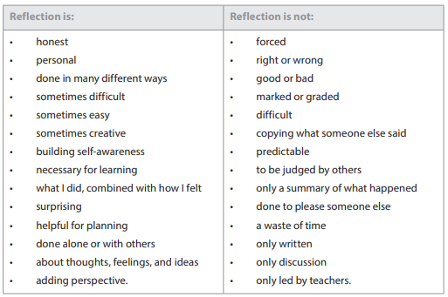
www.ibo.org
Student Resources
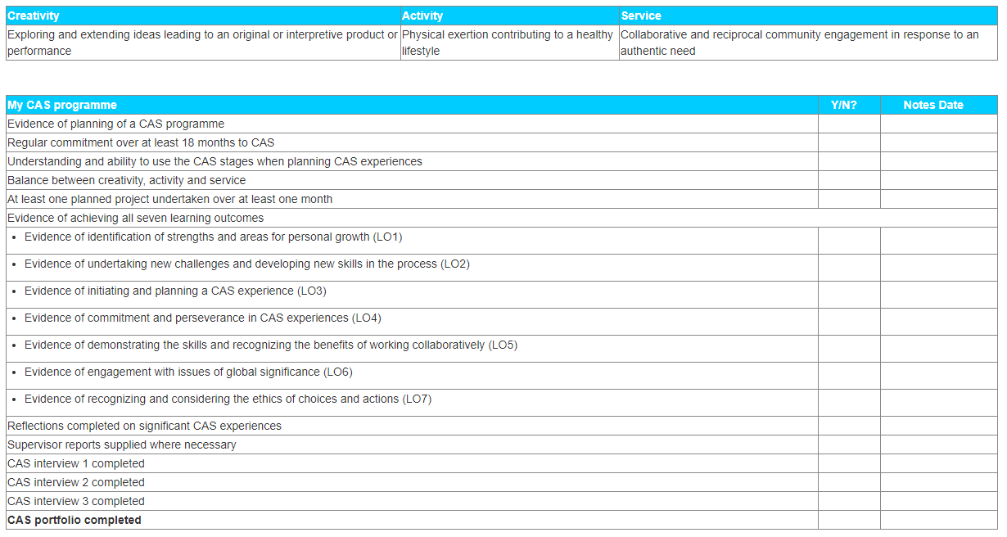
CAS Program Completion Student Checklist

CAS Project Approval Form
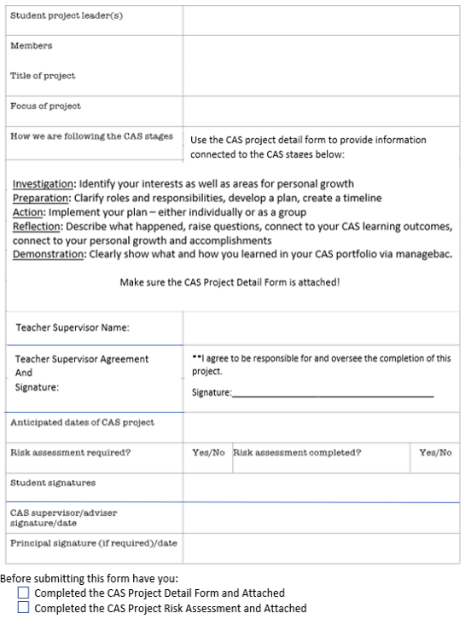
CAS Project Detail Form
Use this sheet to plan out your CAS project. This planning sheet should be submitted at least three weeks before your planned event along with the approval form and risk assessment.
 | Details | Identify the CAS Stage (I, P, A, R, D)
What is your event?
Why are you holding this event?
Explain your goals and objectives.
Who is planning this event? (name of committee/group, or list individual student names. Indicate who the group chair/ contact person is.

Proposed event date & location
Name of teacher who is supervising your group (they must agree to this first!).

Supervising teacher will give guidance for both planning and when the event is held.
What will happen at the event?
(Give an outline of what the event will involve.)
Who will participate in the event? (who is your target audience?)
Anticipated Number of Participants? (Give an estimation of the number of people who will attend)
What Adults will be at your event to help supervise?
How will you measure the success of the event?
List the school resources or facilities you may need to book for the event (include rehearsals)
Will you require money to carry out your event? (if so, how will this be obtained?)
How will you publicize the event?
What are the task/duties of people involved in planning/running the event?
(what is your action plan?)
What needs to be done after the event?
List people/organizations that might be helpful to you in planning/implementing this event.
How will you reflect throughout your project?

CAS Project Risk Assessment

Risk | Likelihood of Occurrence  (1-10 rating: 1 being low to 10 being high) | Control Measures | Action if risk occurs
(if needed, add more rows)

Example from an Athletic Experience:
Risk | Likelihood of Occurrence  (1-10 rating: 1 being low to 10 being high) | Control Measures | Action if risk occurs
Dehydration | 3 - there are water fountains | Ensure everyone has a water bottle and access to water | - Seek medical attention from Athletic Trainer  - Give water
Logging on to Managebac
- Go to: https://www.managebac.com/login
- Enter your HCPS student email address and click find my school
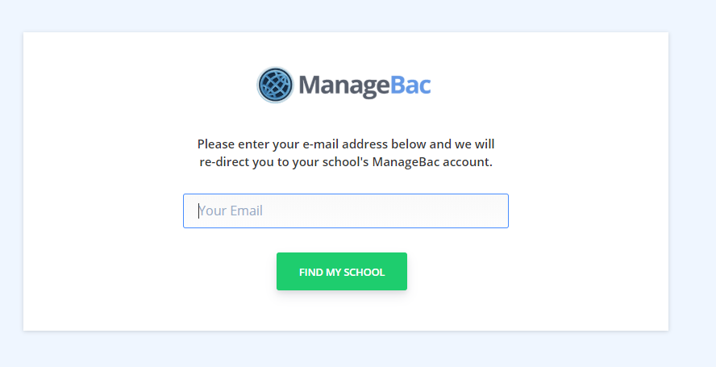
- Enter your password and click sign in (your user name should already be entered)

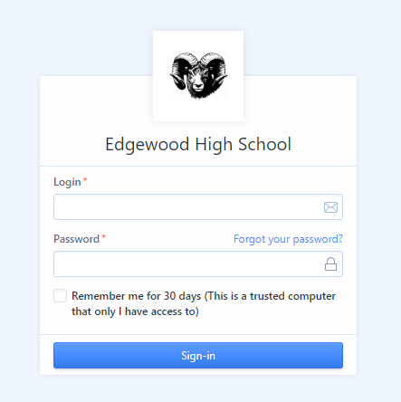
- Navigate to the CAS tab
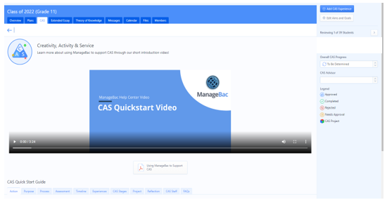
Note: There is a video in the center of the screen to help you get started as well as several informational tabs under the video to help guide you through your CAS program.
Entering A CAS Experience in Managebac

- Click on Add a CAS Experience at the top right of your screen

- Fill in the required information

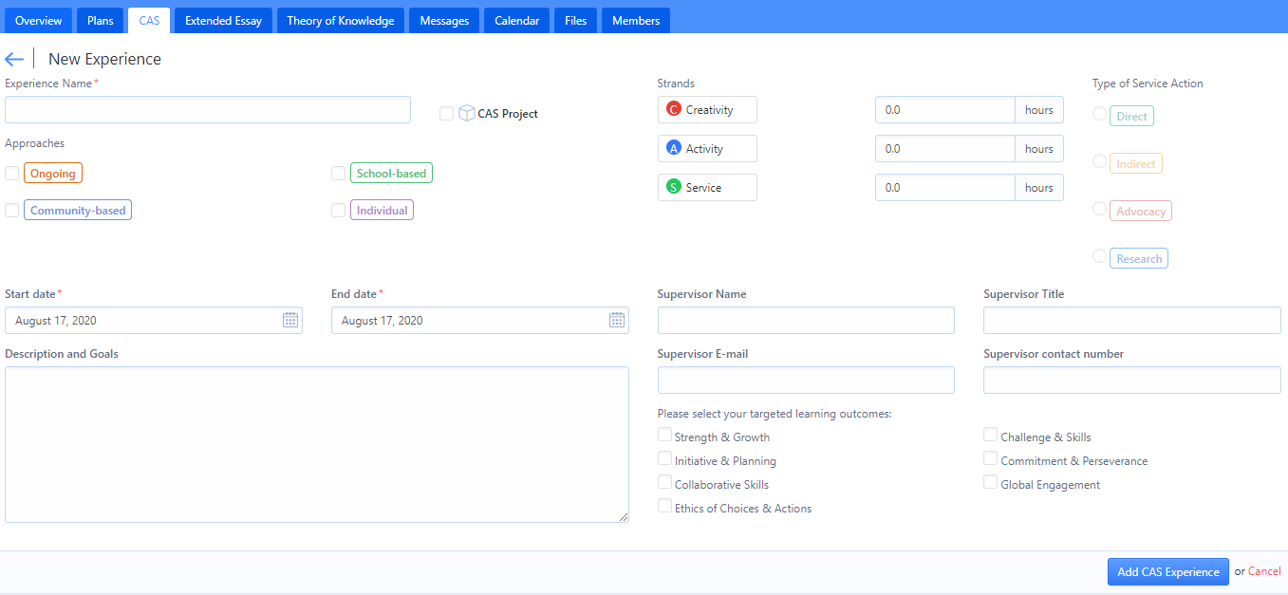

- Click Add CAS Experience. This will then be sent to your CAS Coordinator who will approve it.
  - To be approved – your description and goals has to give your coordinator an idea of what the experience will be about and your overall goals. The coordinator will use this information to approve the experience and make sure the number of hours you listed makes sense.

- Once approved, you can begin the CAS Experience. You will see this symbol next to the experience once it is approved.
Creating a CAS Project in Managebac
- Follow the same steps as enetering a CAS Experience and then check the CAS Project box.

- You will a cube next to the project in your list on Managebac signifying it as your CAS Project.

Reflecting on a CAS Experience/Project in Managebac
- Click on one of your experiences or your project.
- Click on “add reflections and evidence” – you will see it on the top right hand side of your screen

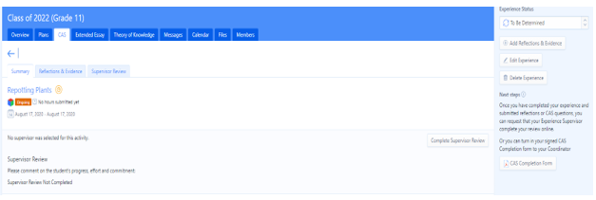

- Type in your reflection using the prompts at the bottom to guide you. When finished, click add new entry.

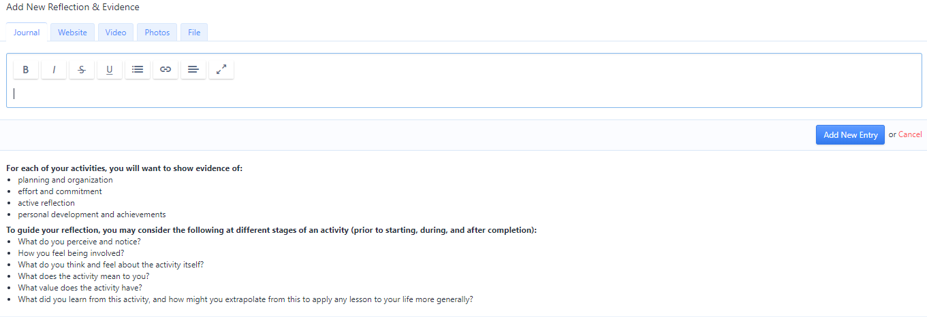

Keep in mind, you demonstrating here that you met the learning outcomes listed for that experience/project The more evidence you can include here the better!! There are tabs for written evidence as well as tabs for video, photos, etc. They all help to provide great documentation that you achieved the learning outcomes you identified.
You can and should include multiple reflections per entry – especially if they are larger in hours inputted. Just repeat the steps above to add in a second, third, etc entry.
Works Cited
Iborganization. (n.d.). International education. Retrieved August 23, 2020, from http://www.ibo.org/

